|  |  |
| --- | --- |
|  |  |
| Literature Review |  |
|  |  |
|  | 2022/2023Cloud Computing |
|  | Margaret BuckleyBernadette Brosnan |

|  |  |  |  |
| --- | --- | --- | --- |
|  |  |  |  |

Contents

Background & Abstract 3

Project Objectives 4

Existing application/Background 5

Cloud 6

Other services 8

Software applications 9

What am I going to use? 12

Database 13

User Interface 17

Plan of progression 18

Useful links 25

**References 26**

## **Background & Abstract**

(Your going to come back to this at a later date)

Less on background

Sosad Ireland has been working to raise awareness and prevent suicide in Ireland since 2007. They have worked tirelessly in the communities to make those in need feel supported and to let them know they are not alone on their journey. Sosad Ireland offers free support and services to people dealing with suicidal ideation, self-harming, bereavement, depression, stress, and anxiety, or simply needing someone to talk to. Sosad offers a 24-hour helpline and free counselling services to anyone over the age of 16, 365 days a year. Sosad has recently added a messaging service to their website, which is available from 8 p.m. to 12 a.m. daily.

This Mental health app will make it simple to find the location of the different offices and give information about the services that the organization has. Users will be able to get the assistance they require simply by using the application, which they will be able to use from anywhere in the world if they have internet access. To resolve any issue that may arise I will be collaborating closely with the managers and volunteers in the Sosad office. The user can apply to be a volunteer at any of our locations. Users will be able to view the office locations.After conducting some research on the competition, I discovered that they only have websites and no mobile apps for people to download, whereas the apps that are already available simply let users keep track of their mood and receive advice on how to take care of their health.

**More focus on concise description of app including technologies used**

## **Project Objectives**

|  |  |
| --- | --- |
| **Types of users** | **How they can use the app** |
| Users | * view the location of the offices. * Apply to be a staff member. * View fundraising events. * Use the chat service. * Listen to real talk videos |
| Staff | * create, edit, delete, update event with. * Respond to messages in the chat service. * View roster. * Notice board. * Upload new real talk videos. |

## **Existing application/Background**

**What is your current competition.**

There are loads of applications that you can get for your mental health on ios and android, but the apps are only there to track your mood only and I will not be doing track your mood in my application. These applications listed below are not linked with organizations. The list below is the competition that I have on iOS and android.

|  |  |  |
| --- | --- | --- |
| **Name of application** | **What it does** | **Device type** |
| Mood kit | It helps track your mood and it will help you with creating positive thought patterns and will help with reducing stress. | iOS |
| Better Help | It connects users with a licensed, experienced therapist for remote teletherapy sessions | Android & website |
| MoodMission | It helpsyou to overcome feelings of depression and anxiety by discovering new and better ways of coping. When we feel down or anxious | Android & iOS |
| Sanvello | Stress relief | Android & iOS |
| Calm | Meditation | Web, Android |
| Happify | It helps users reduce stress, anxiety, and negative thinking, and improve emotional well-being | Web, Android |
| CBT guide to depression & test | Depression | Android |
| Shine | It helps calm anxiety and stress | Android & iOS, web |
| Emoods | Bipolar Disorder tracker | Android & iOS, web |
| Bearable | It keeps track of everything mood symptoms, factors, and sleep | Android & iOS |
| Todoist | ADHD | Android |
| Ptsd coach | PTSD | Android & iOS |

## **Cloud**

**What is cloud?**

A grouping of internet-based computer services known as the "cloud" that comprises servers, storage, databases, networking, software, and analytics offers scale economies, quicker innovation, and adaptable resources. Most of the time, using just the cloud services you require lowers operational costs and enhances infrastructure management. There are several benefits to cloud computing. By setting up what is basically a virtual office using the cloud, you may access your business or application from anywhere, at any time of the day or night, using any web-enabled device. Here are some benefits. (Microsft, UN)

### What are the advantages of cloud.

**Reduced Costs:**

Cloud can help you save money on system management and maintenance. Instead of purchasing expensive equipment, you could cut costs by using cloud service provider resources. (Globaldots, 2018)

**Scalability:**

Your operating system and storage requirements can be scaled up or down to meet your demands, it also provides flexibility in case those needs alter as the project is being developed. Your service provider will take care of everything for you rather than having to buy and install expensive upgrades and using the cloud will free up your time so you can carry on with your day. (Globaldots, 2018)

**Collaboration efficiency**

Communication and information sharing is made easier by collaboration. You could use cloud computing to give you, your group members, or staff access to the same files if you are working on a project together. you don't need to be in your office to be able to get access to the files. You could select this model, which will make it much simpler for you to share your data with group members or staff, but you must be careful to only grant users access to the files that are required and to those who are trained in the field you are working in, to prevent the files from being altered. (Globaldots, 2018)

**The flexibility of work practices**

When you have an internet connection, the cloud will give you more flexibility so that you can access the data from any location. You will be able to instantly connect to your virtual office when you need to view your data while you are out of the office, just as if you were there in person. (Globaldots, 2018)

**Access to automation updates**

This enables you to receive updates for your purpose, which could be part of the service that you signed up for. your system will be continuous b be updated with the newest technologies. (Globaldots, 2018)

**Why cloud**

It will provide you access to your data from any device. It implies that you can access and change your data whenever you want, from anywhere in the world. It also offers a simple method for users to exchange information. You don't need to buy expensive updates or upgrades that traditional software. You just pay for what you use when you use it. The phrase "cloud computing" is used to refer to many different types of technologies. These services range in price, with some being cost-free. Some of the most popular kinds of cloud computing solutions are listed below:

**PAAS:**

Companies that use this model do not pay for hosted apps; instead, users pay for any components needed to create their applications. Online vendors provide everything needed to build an application, including the operating system and infrastructure. (Microsft, UN)

**SAAS:**

This is a method for offering apps online as a service. By simply using software that is accessible via the Internet rather than installing and maintaining it, you can avoid difficult software and hardware maintenance. (Microsft, UN)

**IAAS:**

The term "Infrastructure-as-a-Service" (IaaS) is used. Consequently, this will let businesses purchase resources like networking and storage on demand rather than having to purchase expensive hardware. IaaS is incredibly scalable for businesses and much more flexible than on-premises solutions. This is the underlying layer of cloud computing. (Microsft, UN)

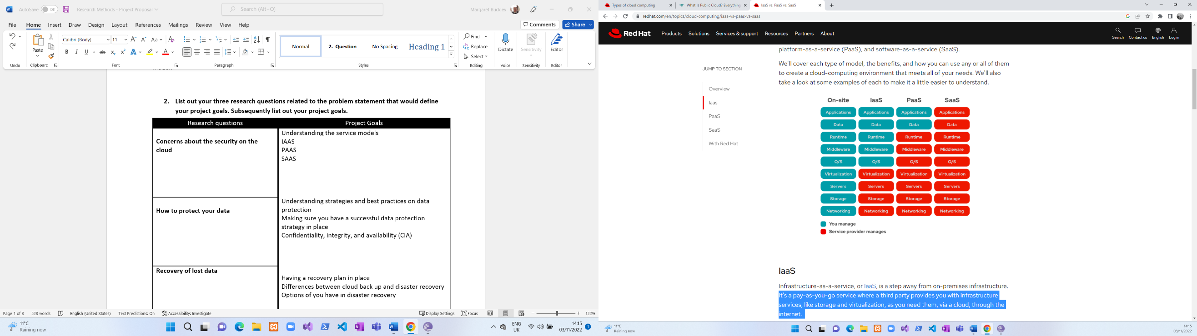

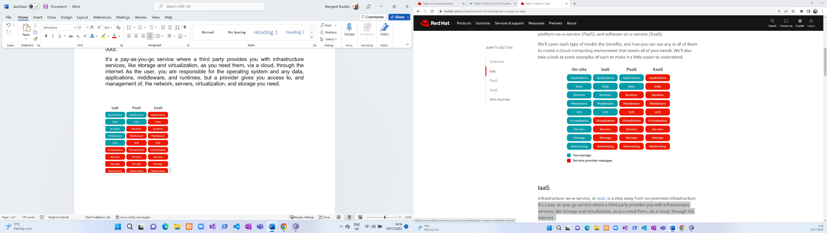

## **Other services**

**What other Mental health organizations are there and what application type have they got?**

Here is a list of various organizations that promote mental health, although none of them have a functioning application that can be downloaded that I am hoping to achieve by creating.

|  |  |  |  |
| --- | --- | --- | --- |
| **Name of organization** | **What you can do** | **Application type** | **What it is** |
| Jigsaw | * Newsletter * Donate * Select local jigsaw near you. * Office locator * Chat service * Employment options | Website | Mental health advice and support – online and in person – for young people aged 12 to 25 years old, and for parents or concerned adults.  (HSE, UN) |
| Childline | * Chat service * Advice on different topics | website | Ireland's 24-hour listening service for young people up to the age of 18. Childline is a service from the ISPCC. (HSE, UN) |
| Belong to youth services | * Contact form. * Donate * Newsletter * Volunteer form * Events | Website | Support, information, and groups for lesbian, gay, bisexual, transgender, and intersex (LGBTI+) young people in Ireland, their parents and carers, and other professionals. (HSE, UN) |
| spunout | * Accessibility tools (text size) * Volunteer form * Donate * Quiz * Advice | website | spunout is Ireland’s youth information website created by young people, for young people. Articles and information for young people on many topics, including mental health. (HSE, UN) |
| Barnardos | * Login/ register/reset password * Donate * News/events * Forms | Website | Services for children, families, and communities, to transform the lives of vulnerable children affected by adverse childhood experiences. Barnardo’s also provide a Children's Bereavement Service. (HSE, UN) |
| Cari | * Donate * Request a call * Podcast * Forms * Events/news | website | Therapy for children and young people who have been affected by child sexual abuse. CARI also provide information, support and counselling to non-abusing parents, carers and siblings. (HSE, UN) |
| Pieta house | * Donate * Events | Website | We provide a professional one-to-one therapeutic service to people who are in suicidal distress, those who engage in self-harm, and those bereaved by suicide. (HSE, UN) |

## **Software applications**

**What is a software application?**

Mobile apps are software programmes that are created expressly for use on mobile computing platforms, such as smartphones and tablets, as opposed to desktop or laptop PCs. Depending on whether they are web-based or native applications—those made particularly for a given platform—mobile apps can occasionally be divided into four groups. The characteristics, advantages, and disadvantages of each category are discussed here. Additionally, you will discover the many tools that can be utilized by each group. (Ivy, UN)

**Web-app:**

A web application is any piece of software that operates in a web browser. The application is dependent on a web browser to be rendered because it is built in a programming language that is supported by browsers, such as JavaScript, HTML, and CSS. Web apps are therefore software programs that enable website visitors to upload and download data to and from databases using their preferred web browser. The online application uses a web server to dynamically generate the information (in a certain format, such as HTML using CSS), which is then displayed to the user within their browser. (Contributor, 2022)

**Native app**

A software programme is created specifically for the iOS or Android mobile platforms and written in a particular programming language is known as a native app, often referred to as a native application. Java is used to create native Android apps, while Swift or Objective-C is used to create native iOS apps. (unknown, 2022)

**Hybrid**

An app that was designed to work on various platforms is referred to as a hybrid app. This third option is a hybrid built from a single codebase that combines features of native apps and web apps. Instead of rewriting apps in the languages unique to each operating system, developers can create a single programme that can be downloaded from all app stores. Simply put, to support mobile devices running both Apple OS and Android, a single codebase only needs to be written once. Hybrid apps use coding languages with integrations and plugins to offer this functionality. (Lannace, 2021)

**Cross-platform**

Cross-platforms are designed to work across several mobile platforms such as windows, blackberry iOS and Android With a single coding system, programmers may create apps that can operate on a variety of platforms. As a result, the app can be created more quickly, it will have higher quality, and it will work on various platforms. (Jackowski, 2020)

**Justification:**

I have chosen to go with a cross-platform because it will reach other to users that use IOS, Android, web applications.

|  |  |  |  |  |
| --- | --- | --- | --- | --- |
| PLATFORM | TOOLS | ADVANTAGES | DISADVANTAGES | BENEFITS |
| *Web-app* | * Angular * Jquery * Bootstrap * react * typescript * angular * postman * Xampp   (UN, UN) (devs5003, 2022) | * It is cheaper than others. * it is kept up dated. * it is easy to run the application.   (Itrobes, 2021) | you need to have access to the internet.Website DependencyIt is not as fast as others.It is not as secure as others. (Itrobes, 2021) | * It allows all users to access the same version of the application on different devices. * It does not need to be installed on the device. |
| *Native* | 1. Object-C (IOS) 2. Java (android) 3. C# (windows phone) 4. Swift (IOS) | 1. Speed 2. You can work offline. 3. It will look good and is user friendly.   (Khan, 2018) | 1. Lengthy downloading process 2. No flexibility 3. Expensive when developing 4. Time-consuming 5. It requires constant upgrades.   (Khan, 2018) | Native platforms deliver the best results.Native platforms are more secure.They enable access to all of the device features for the developers.Native applications have Fewer Bugs during Development (Khan, 2018) |
| *Hybrid* | 1. JavaScript 2. Ionic 3. Typescript 4. Angular | 1. Fewer development times 2. Cheaper 3. Wider audience 4. Much easier to fix bugs and the maintenance of application. 5. Scalability   (Iannce, 2021) | 1. Operating is slower. 2. Longer testing process 3. Playing catch up on platform update. 4. Less complex functionality   (Iannce, 2021) | 1. It can be used on IOS and android. 2. It can work offline. 3. The development time is much faster compared to native |
| *Cross-platform* | 1. Ionic 2. Node 3. Native script 4. Reactive Native   (TechMango, 2022) | 1. Sharable code 2. Faster development time 3. Wider audience   (TechMango, 2022) | 1. Poor design 2. Limited functionality 3. Updating delay   (TechMango, 2022) | 1. You will be able to reuse code. 2. Code will be used on multiple platforms. 3. It has high performance. 4. It also will reach out to different user groups.   (TechMango, 2022) |

# 

## 

## **What am I going to use?**

I chose to create a cross-platform application because it allows users to access the application on multiple platforms such as iOS and Android. Because it is on both iOS and Android, I will have a broader range of users than native apps. It is also more convenient and dynamic than native apps. After researching what a cross-platform app is, I discovered that most cross-platforms are based on cloud technologies and can integrate with various frameworks that come with ready-to-use plugins. So, when an app is developed for iOS, it will look and feel the same on Android as it does on iOS. Because the app will be available on both devices, there is a greater chance that more people will use it.

***Security:*** when a user registers to the system I will be enabling authentication in firebase so that the password gets encrypted automatically so it is unreadable.

**API:** An API will be used for google maps so you can find the location of all the offices that we have across Ireland.

**Cloud:** I will be using the cloud for storage in firebase for uploading images for events and uploading new videos.

**Database:** I will be using a non-relational database and I will be storing the data in firebase

**Ionic:** this will be used for the code to make the application work

**Angular:** this will be used to make the application user friendly

I am hoping to create an application that will work on all devices such as IOS and android as it will give me a broader range of users.

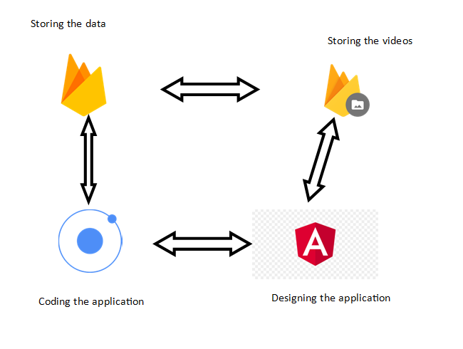

## Database

**What is NoSQL?**

Databases are built to handle both massively parallel, high-performance data processing and large-scale data storage on a variety of commodity hardware. NoSQL offers a mechanism for you to engage with data that is more closely tied to the application than the conventional relational database strategy does. NoSQL databases often function as clusters of several machines that are distributed systems. Each piece of data is copied among those machines to offer redundancy and high availability. NoSQL databases can hold vast volumes of data in a distributed manner, making them simpler to develop and deploy. (devs5003, 2022)

**What is MySQL?**

SQL, a structured query language, is used by Oracle to develop MySQL. The database, which holds a tonne of data, is made to collect information from websites. MySQL is an open-source database that enables a user or business to edit; it is typically linked to online applications or web services. The data that people enter on a website is stored in MySQL. Users can connect to many websites using the MySQL database. It is an open-source database that enables you to handle your data with this programme in an efficient manner because it is a very powerful, dependable, and robust option. The following is a summary of some advantages of using MySQL.

**Benefits of relational database:**

**Scalability on Demand**

This platform's remarkable scalability can help with the management of embedded applications. This holds true even if there is a sizable data warehouse. One of the primary features of the system is its capacity to change on-demand.

**High Efficiency**

The unique storage engine used by MySQL makes system administration simpler. The MySQL database server's performance can also be improved. In other words, you can still benefit from this technology even if you have a fast computer system or a website that receives millions of visitors every day.

**Outstanding Transactional Support**

MySQL is at the top of the list of today's fast transactional database solutions. It has several features, including consistent and automated transaction support.

**Relational database**

This kind of database will keep information in several tables with rows and columns. Each database table relates to a certain entity. Examples include clients, goods, orders, etc. It is the primary distinction that distinguishes relational databases as unique. Since every table in a database may communicate with any other table, this will make the data flow flexible.

I had originally decided to go with relational database because I was familiar with it and had used it before, but I decided against it as I wanted to learn something new and a lot of what I wanted to achieve didn’t necessarily need to have a relationship between the different tables. In image 1 is an example of what my MySQL database would have looked like if I had of decided to go with that.

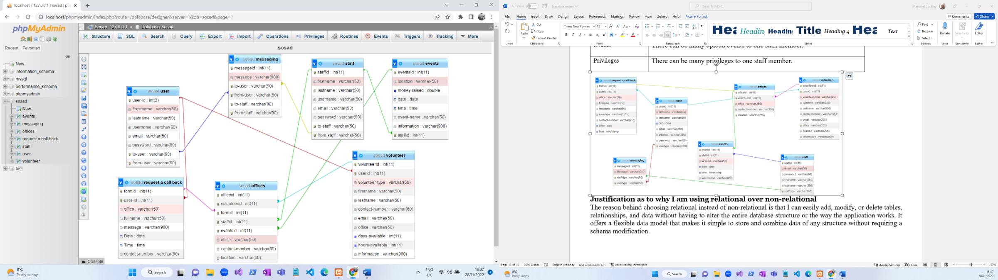

**Image 1**

**Non-relational**

There are no tables, rows, primary keys, or foreign keys in this form of database, unlike relational databases, which use these features to store data. Unlike relational databases, this type of database does not include several connected tables. (Pattinson, 2022)

**Column-oriented databases:**

As you can see in the database that I am using for a non-relational there are three sections, collection, document, fields.

In firebase you can see below that it stores all of its data in the form of collections instead of tables and the collection consists of documents and each document has a field and that has values like key value pair. A field can be made up of different types such as string, numbers, array, and Booleans etc. but in this database, I will be using strings and numbers.

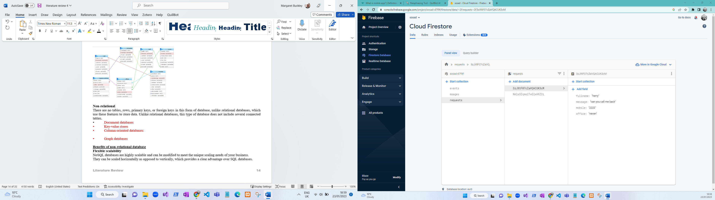

**Benefits of non-relational database**

#### **Scalability**

#### Because NoSQL databases are so scalable, they can be scaled to meet the demands of your company.It offers a definite benefit over SQL databases, which can only expand vertically, not horizontally. NoSQL databases can scale horizontally since the data is unstructured. Each component is independent and self-contained since NoSQL databases need less structure than SQL databases. By keeping them all on separate servers, this eliminates the need to link the items together. (Pattinson, 2022)

#### **Data types**

With NoSQL databases, you can store and retrieve data with little to no adherence to the predefined structure. As a result, you won't need to alter the table structures, indexes, or other components for your application to respond to the addition of new information types. (Pattinson, 2022)

#### **Data storage**

Many NoSQL databases' capacity to handle enormous datasets can be useful for real-time analytics and other big data applications. To store structured data on the cloud at a scale that allows for simple addition and deletion without any delays or disruptions, for example, the distributed storage system Bigtable was developed. This type of data can be instantaneously pulled from Bigtable and provided access control support at all levels, down to specific fields inside your documents, without the need for additional security layers. Since there are no single points of failure, it can store an infinite quantity of data. (Pattinson, 2022)

#### **Simplicity**

Many NoSQL database management systems just require only a small amount of code to get started for developers. One NoSQL database management system that enables programmers to store data in flexible formats and retrieve it using code written in any language they choose is called MongoDB. (Pattinson, 2022)

#### **Maintenance**

NoSQL databases won't need as much ongoing database maintenance as traditional relational databases because they can automatically divide and copy data among nodes. Costly hardware, such as standard SQL-relational databases, new IT infrastructure, vendor support, or pricey software won't require as much financial outlay from your business. (Pattinson, 2022)

**Justification**

I’m choosing to use a non-relational database because it performs faster as it does not use queries and it doesn’t have to view several tables to perform the task at hand.in previous years I have used relational databases, so I am going to learn something new.

**Authentication in Firebase**

in the authentication section in firebase, you can enable different authentication factors and when a user's information is inserted into the database their password is encrypted and becomes unreadable to a hacker. You also have the option for sign-in methods in firebase as seen below in the images. In firebase you have the option for the different authentication login but in this project, I have selected that the user logins in using their email and password. You can see in the image below the different types of authentications.

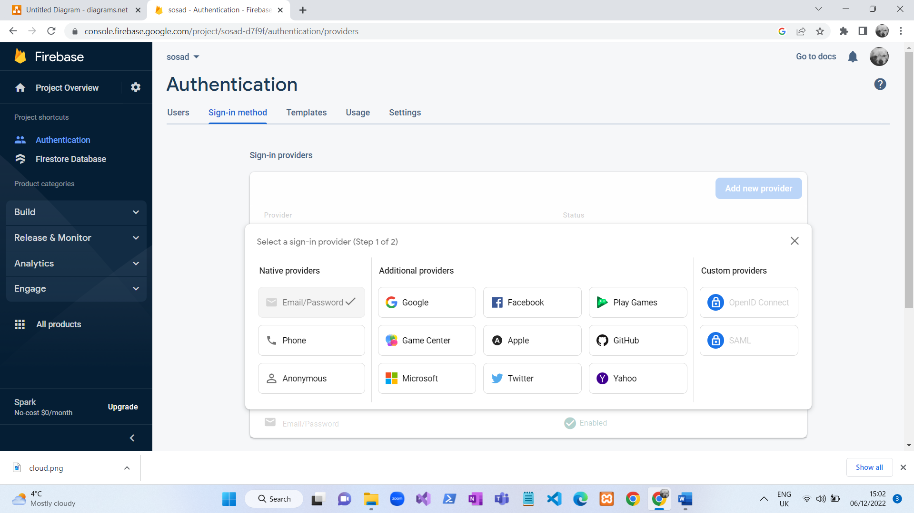

In this image you can see the different documents in the database that I will be using. None of these will have any relationship so if I have to alter anything in the code it will not affect the database as the documents are not related to each other.

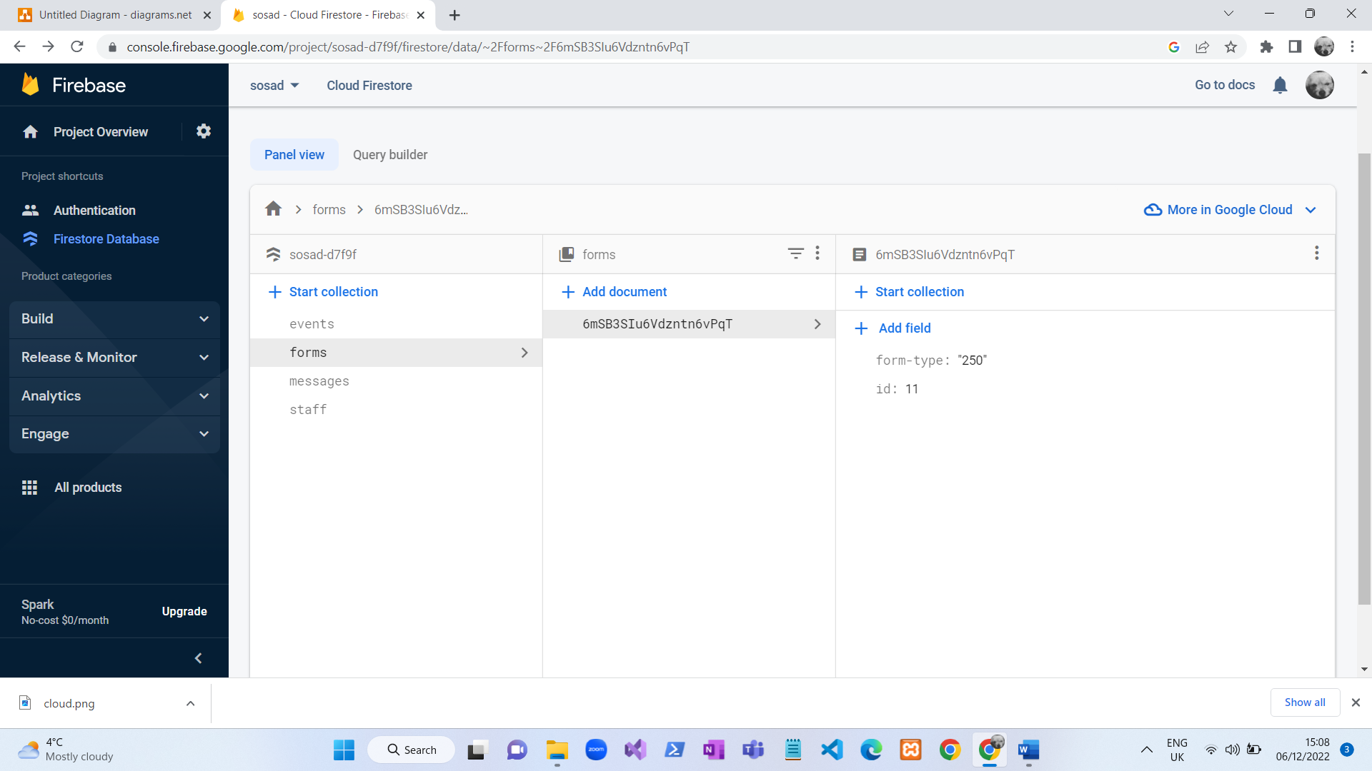

**Encryption:**

I have enabled that all users’ passwords are encrypted so their password cant be read, this is good practice because it makes the users account secure and it makes the password unreadable to anyone.

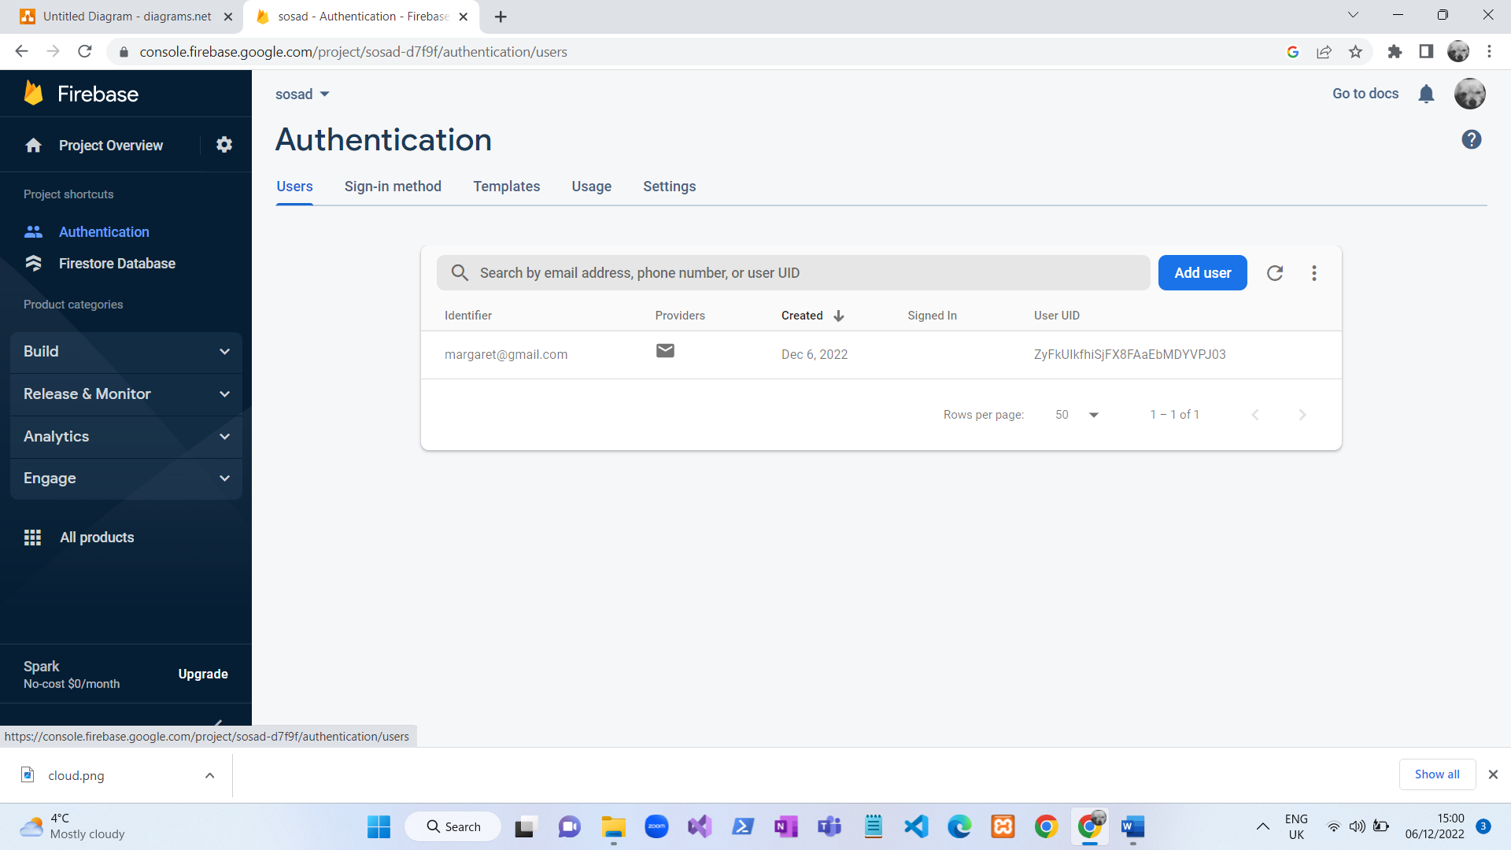

## **User Interface**

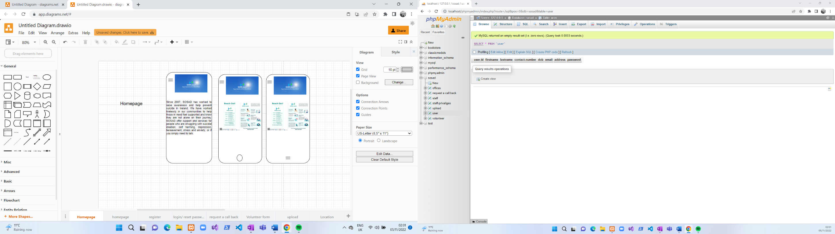

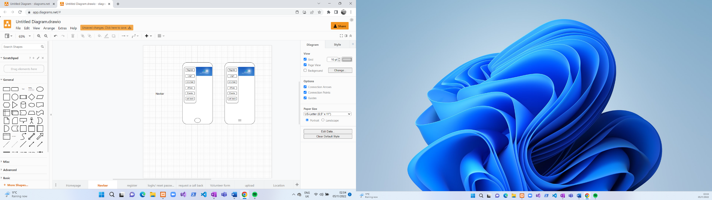

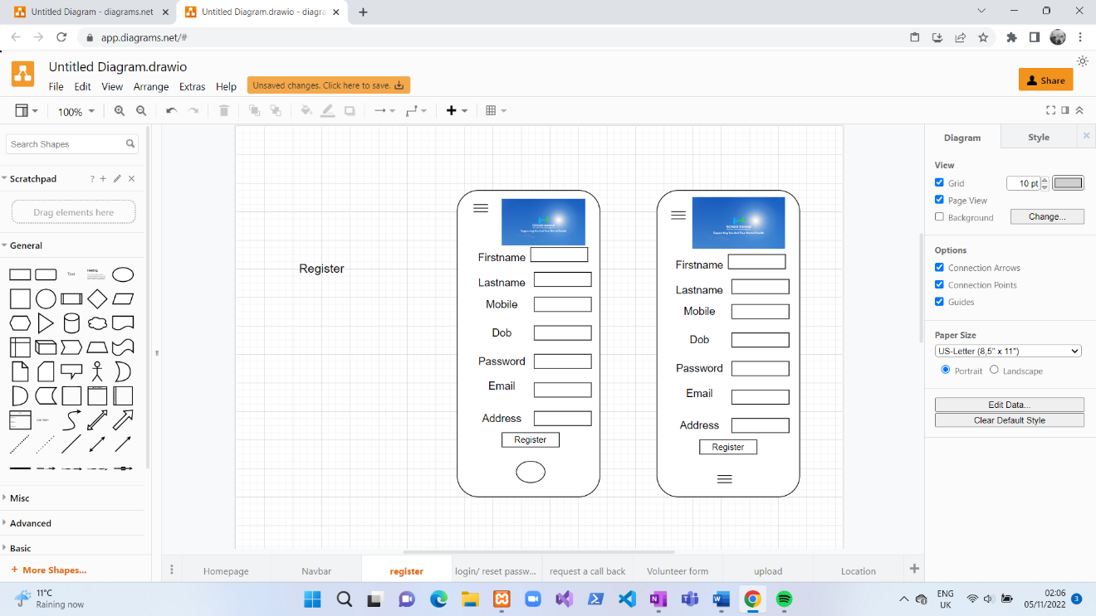

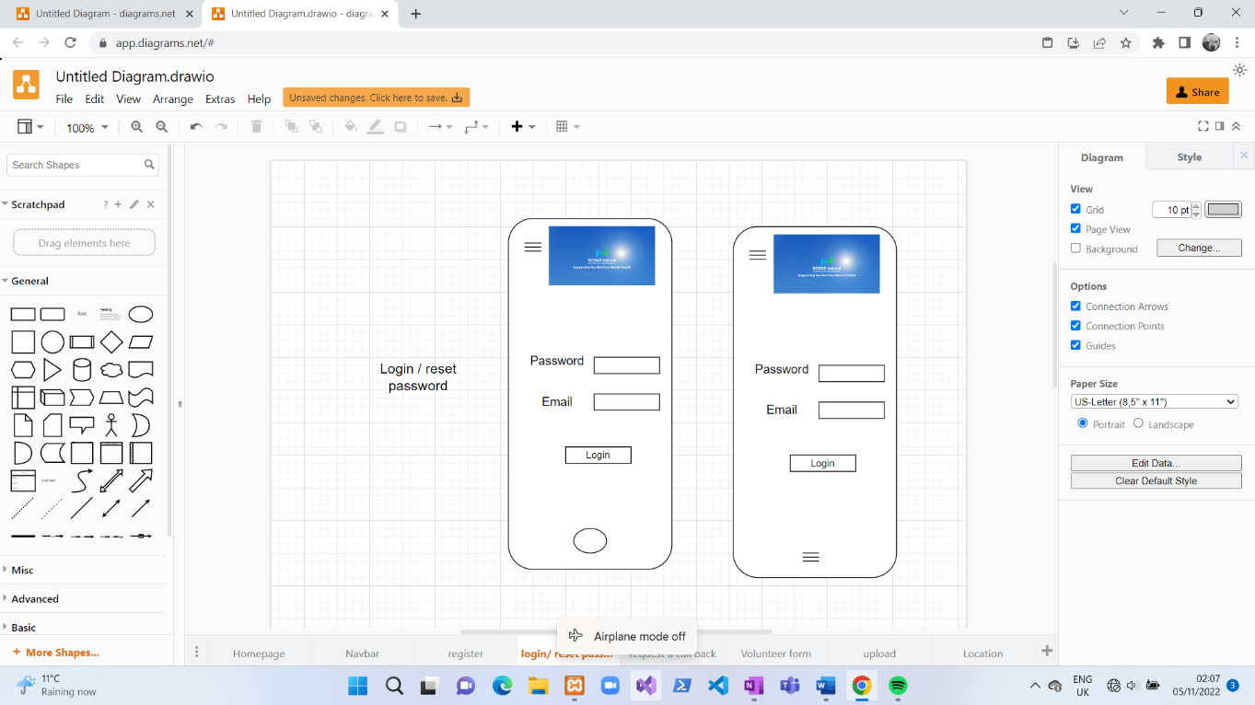

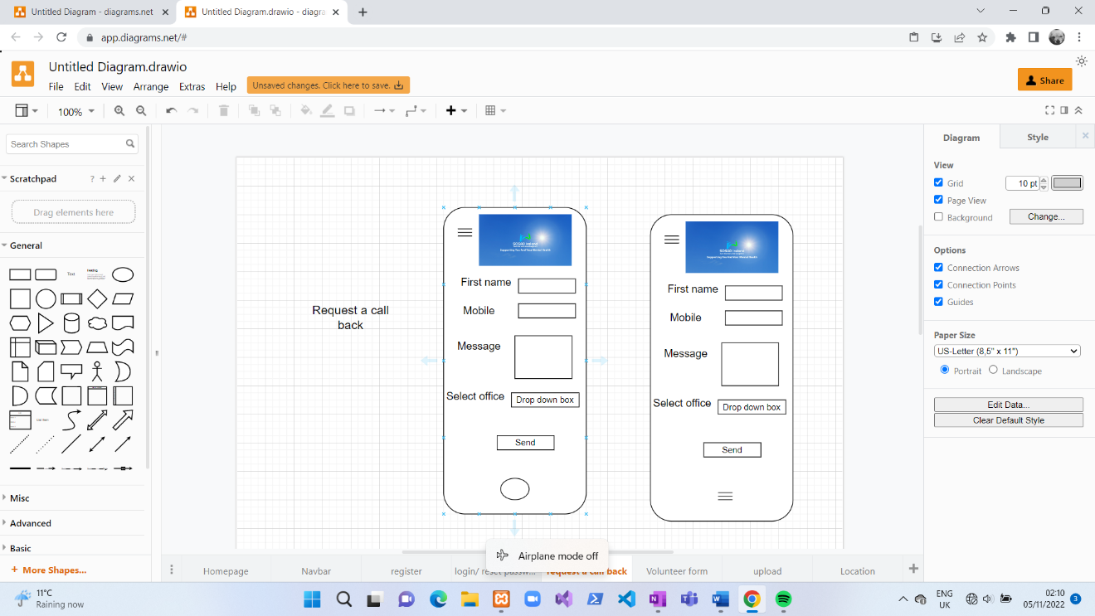

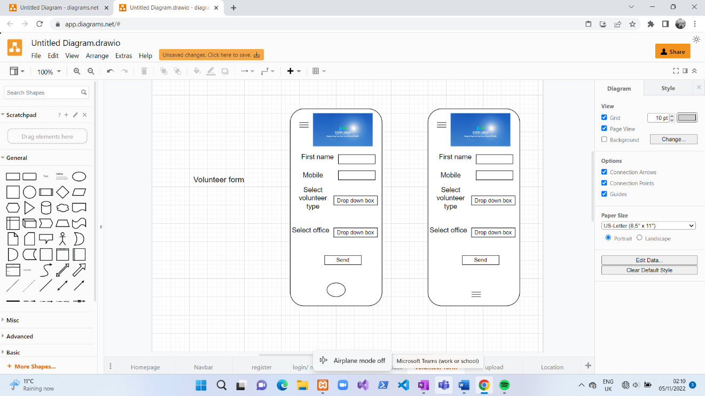

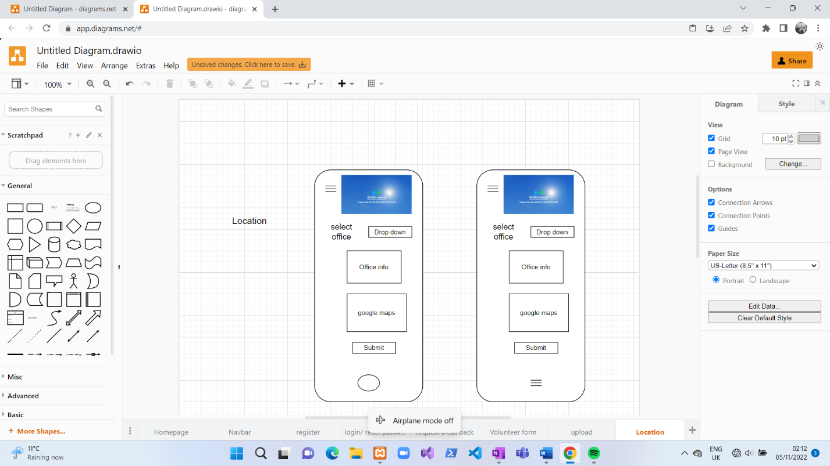

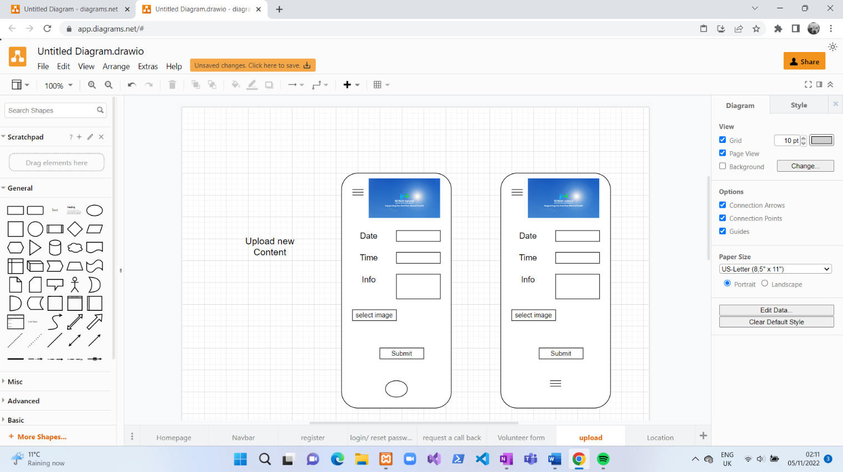

## **Plan of progression**

## Week 1:

|  |  |  |
| --- | --- | --- |
| **Going to do** | **Tasks** | **Date Completed** |
| Registration/login | * to use the application the staff will need to register and login whereas a member of the public won’t need to register or login. * Add the CSS and registration and login. | 27/01/2023 |
| Google maps | * A user will be able to search for the location of the different offices that Sosad has. * Make user friendly so the user can search for a certain office. | 27/01/2023 |
| Events | * Add up and coming events to the application. * Add the interface to the application. * Allow users to view the added events | 28/01/2023 |
| Request a call back | * Allow members of the public to send a request a call back. * Allow staff to view the request a call backs once they are logged in. * Add the edit function so staff can edit the call back form. * Allow staff to delete the old request a call back. * Add the interface to the application | 29/01/2023 |
| functionality | Add the functionality to the application so the application works the way it supposed to. | 31/01/2023 |

**Issues raised in week one:**

The main issue I had was when I created the google maps on its own to make sure that it didn’t affect the other aspects of the application it worked fine but when I implemented it in with the rest of the application it wouldn’t run, I suspect it has something to do with the libraries for google maps.

## Week 2:

|  |  |  |
| --- | --- | --- |
| **Going to do** | **Tasks** | **Date Completed** |
| css | Apply the necessary changes to the interface. | 12/02/2023 |
| Office location | * Allow the public to view the office location. * Add the interface to the application so it becomes more readable to the user | 13/02/2023 |
| Cloud storage | * Allow staff member to upload new content to the app. * Allow the public to watch video. * allow public to have the option to download the video. | 11/02/2023 |

**Issues raised in week two:**

I can’t find a solution to my previous issue with google maps so I will have to change the api idea to something else. I am not fully happy with my CSS now so I will leave it to the end and come back to it.

## Week 3:

|  |  |  |
| --- | --- | --- |
| **Going to do** | **Tasks** | **Date Completed** |
| Fix the database issues | Apply any changes to the database to make it work correctly | 16/02/2023 |
| Restructure Literature review | Apply changes to the objectives.  Add background to the existing applications and other services.  Apply changes to my plan of progression.  Apply changes to the headings to certain parts of the report. | 17/02/2023 |

**Issues raised in week three:** putting the application on my phone was extremely hard as the google maps plugin wouldn’t uninstall, so that forced me to uninstall everything on my app and reinstall them again which then the google maps was uninstalled, which then I realized that my app no longer worked properly so I had to create a new application which took some time but I got there in the end. Then when I was trying to setup the app on my phone, but it was telling me that I had an old version of java, so I had to then download the latest version then when it was installed, I had to change the file path in my system variables on my laptop to the latest version of java when that was done, I was able to install the app. The firebase was setup wrong, so I had to change something in the rules to stop the api-key from expiring. I am going to be taken the google maps idea out as it is affecting the application.

## Week 4:

|  |  |  |
| --- | --- | --- |
| **Going to do** | **Tasks** | **Date Completed** |
| Make any necessary changes to the report (if any) | * apply changes to the project objectives. * Existing application/Background * apply changes to the other services. * Add updates to my Journal! * apply changes to the background & abstract | 23-02-2023  Till the  24-02-203 |
| Make the rosters | * create a roster so the staff can insert their availability to the roster. * Create the interface for the roster. | 25-02-2023 |
| Have the upload section working (for images and videos) | Look into how to upload an image to the database |  |

**Issues raised in week four:** this week for I am having issues with deleting availability on certain dates, update it. having all the typescript code for the different features for the calendar could be an issue. Currently every time I put in a availability it goes into the first one instead of it being inserted into the day and date. I will have to come back to this one after I come up with a solution for it

## Week 5:

|  |  |  |
| --- | --- | --- |
| **Going to do** | **Tasks** | **Date Completed** |
| Make any necessary changes to my application if it’s not suitable on the phone | * Adjust the application so it runs on all devices. | 10/03/2023 |
| Roster | * Allow Ios to insert the dates that they are available to be on call. * Allow all staff to view who is on call on what date. * Add the interface to the application. | Partly completed.  10/03/2023 |

**Issues raised in week 5:**

Database: when an Ios insert their name and the office they work in and the date they are available on, displayed fine but what if the manager wanted to search for people who was on call by date and display everyone that is available for that. In order to allow that to happen I have to create a document in the database called rosters and then create another document in the roster document and have the second one display the date that has been selected. Below is the amount of attempts I made to achieve having a document in a document.

Attempt 1:

Code: await this.firstore.collection("date").doc(this.formatteddate).collection("").add(roster)

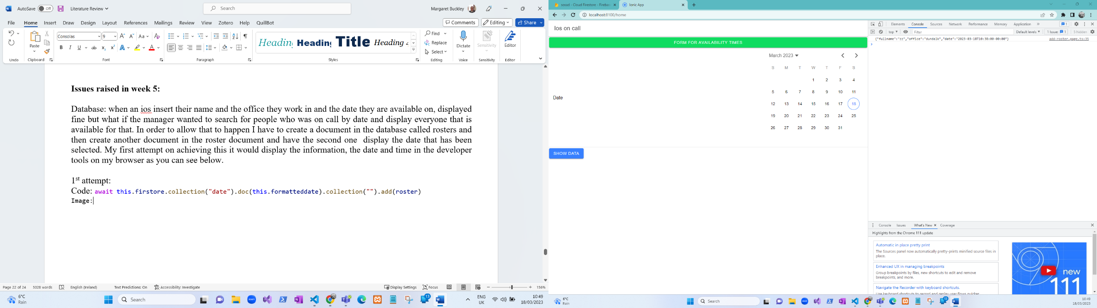

Developer tools:

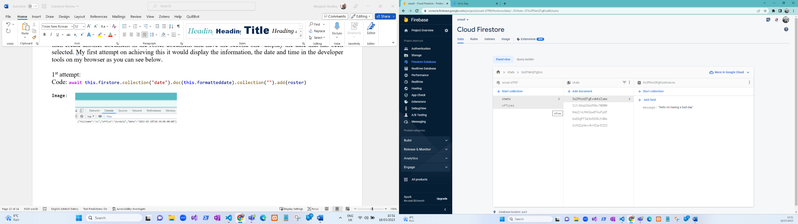Database:

**What happens here:** on the first attempt it doesn’t insert into the database, but it shows in the developer tools what you inserted in the form and it is displaying the time you inserted the data.

Attempt 2:

Code: await this.firstore.collection("rosters").doc(this.formatteddate).set({"key":this.firstore.collection("dates").add(roster)});

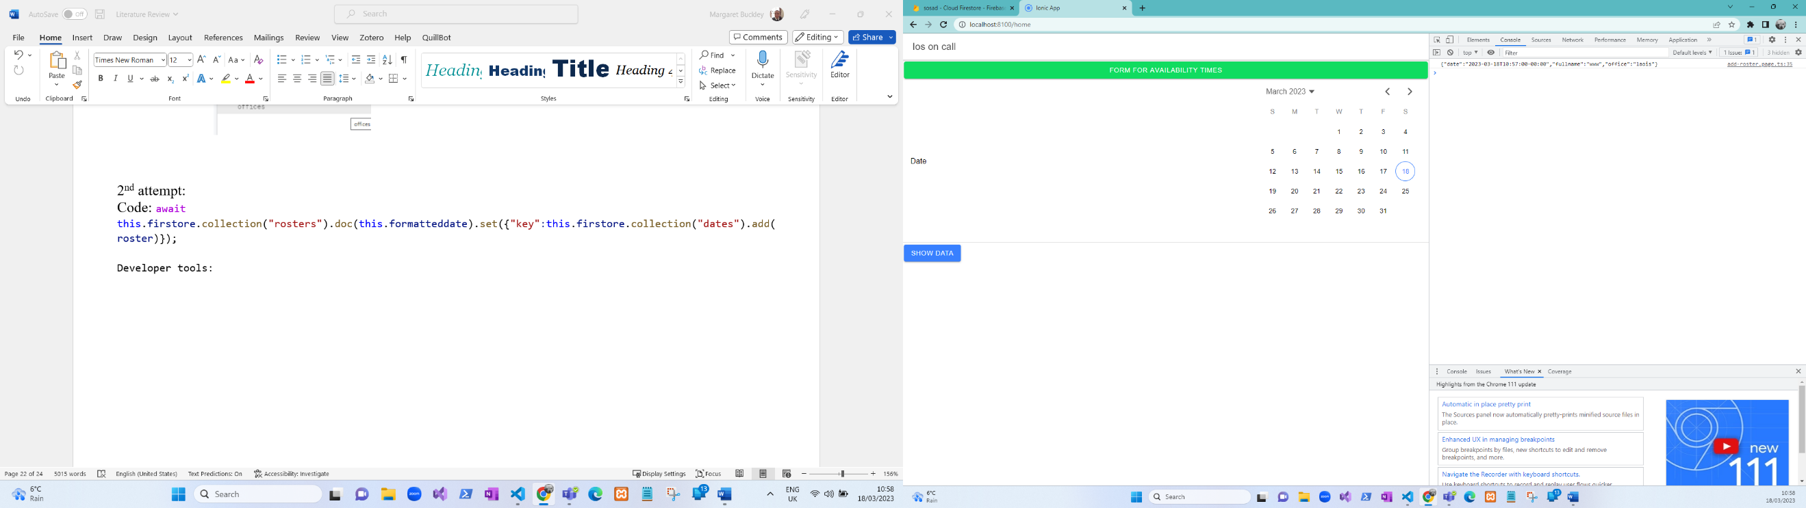

Developer tools:

Database:

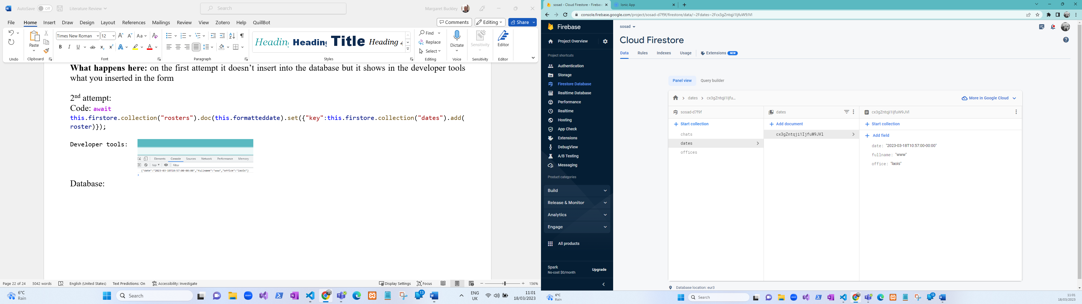

**What’s happening here:** now the data is being inserted but its still displaying the time you inserted the data on and it doesn’t create a document in a document.

**Attempt 3:**

**Code:** await this.firstore.collection("roster").doc(this.formatteddate).collection("rosters").add(roster)

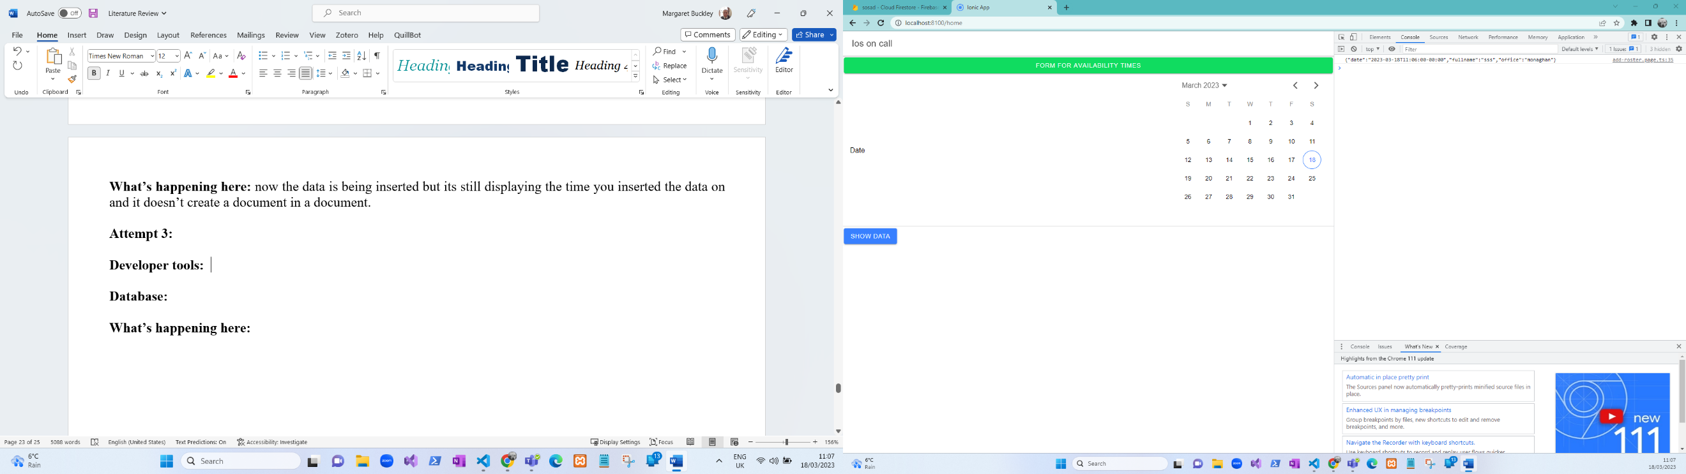

**Developer tools:**

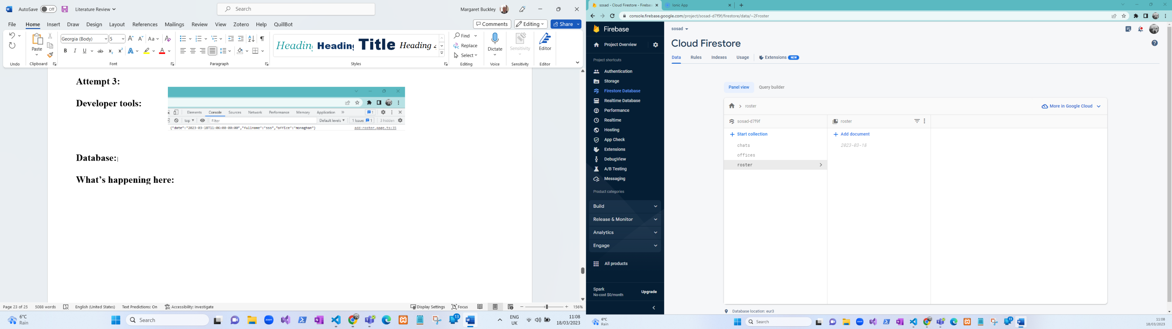

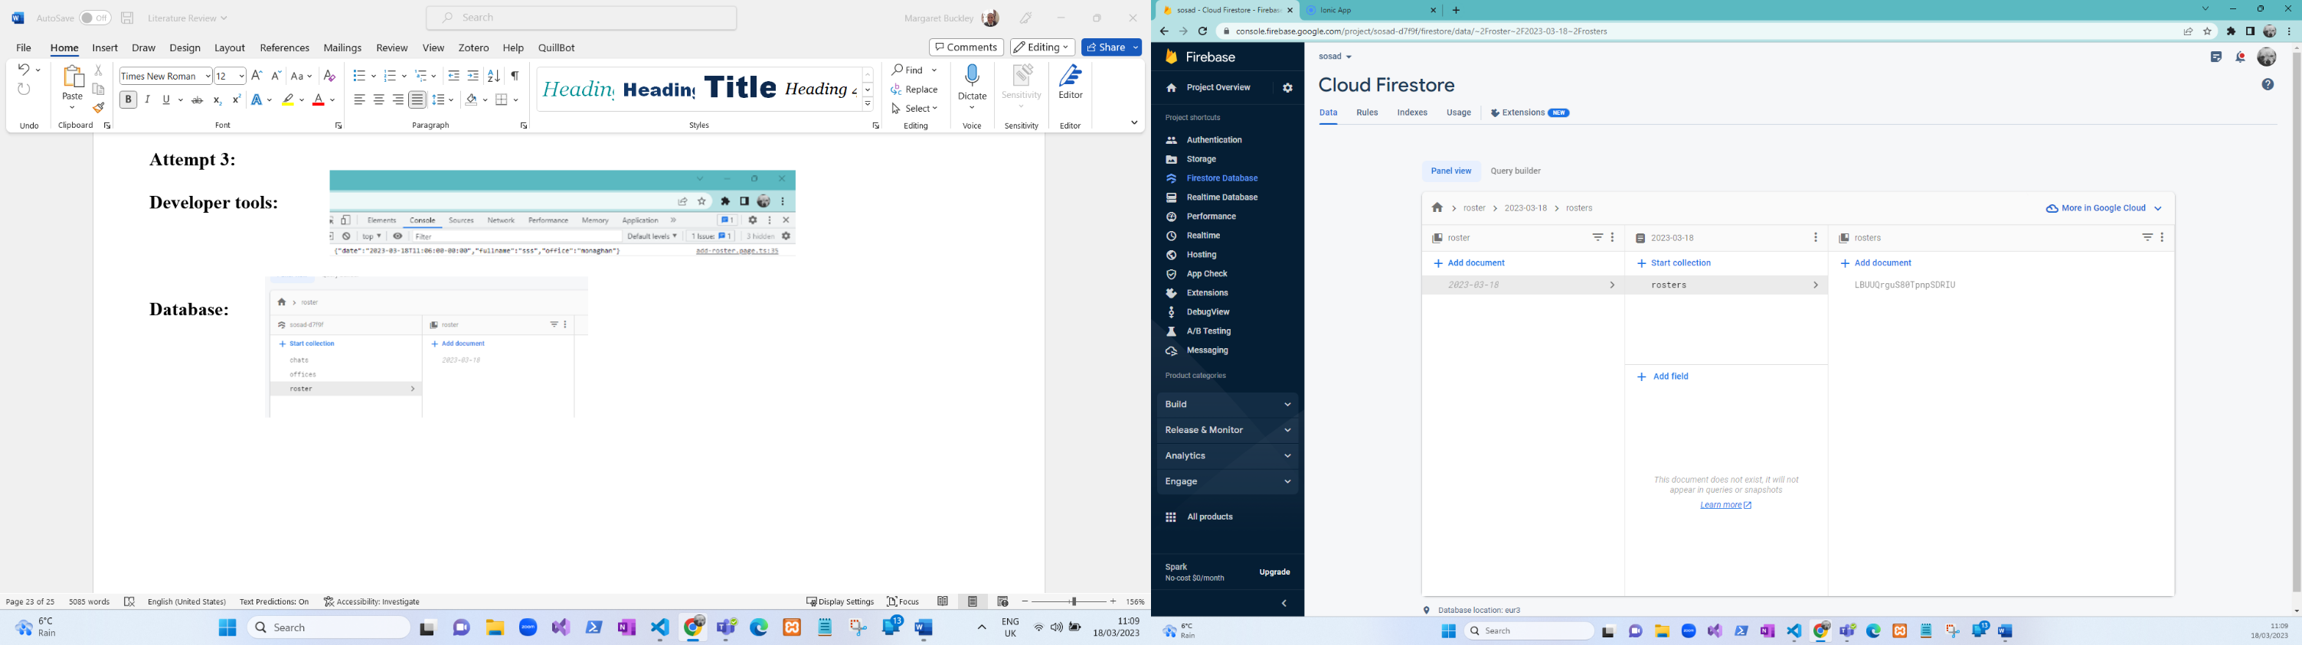

**Database:**

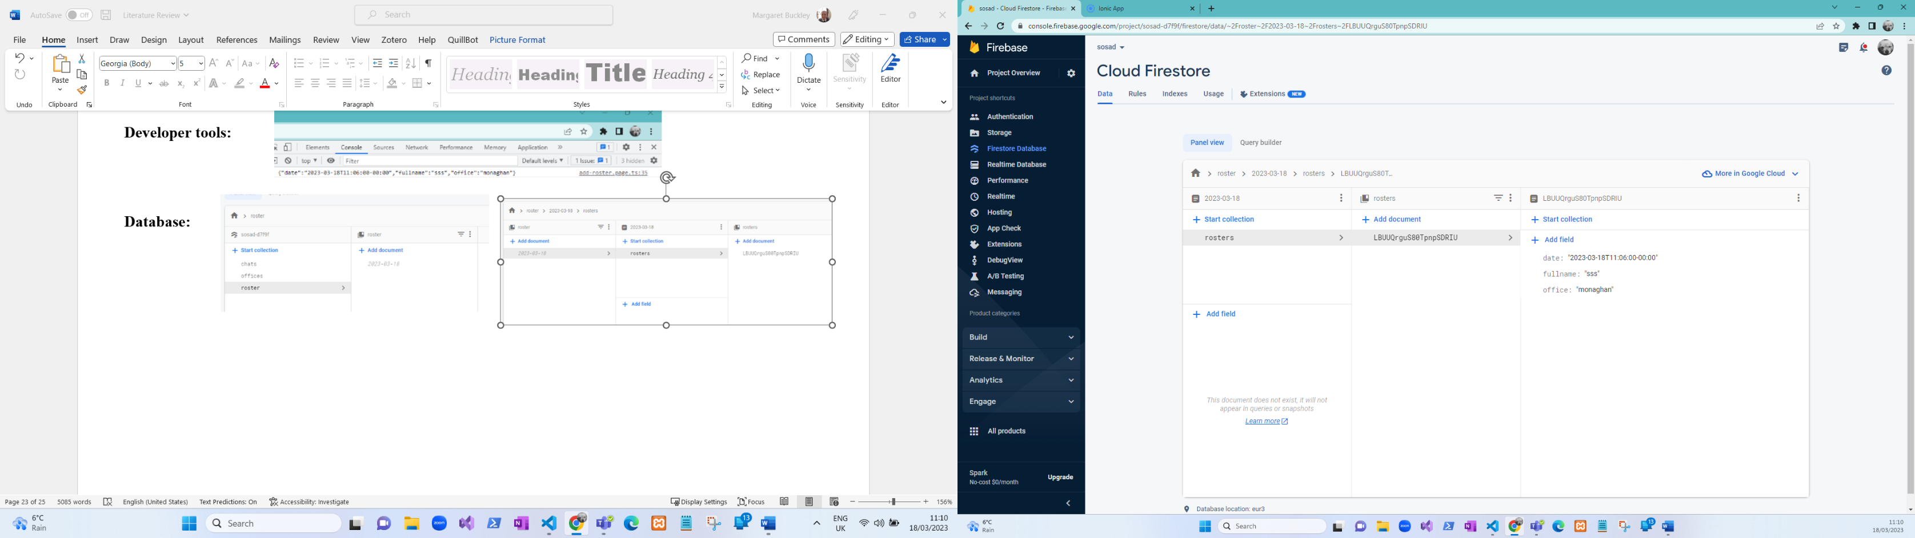

What happens here: so now when the Ios insert their data into the database it is stored in a document called roster then the second document is called by the date that has been selected and in the second document it displays the Ios information.

## Week 6:

|  |  |  |
| --- | --- | --- |
| **Going to do** | **Tasks** | **Date Completed** |
| Roster | * Adjust the code so it will display the data when a date is selected |  |
| Chat | * Allow all staff and users to chat back and forth with each other. * Add the interface to the application | 31-03-2023 |

**Issues raised in week six:**  the issue that I am having this week is when a date is selected it wont display the data.

Attempt 1: let formatteddate = this.formatteddate(this.selectedDate)

 console.log(formatteddate);

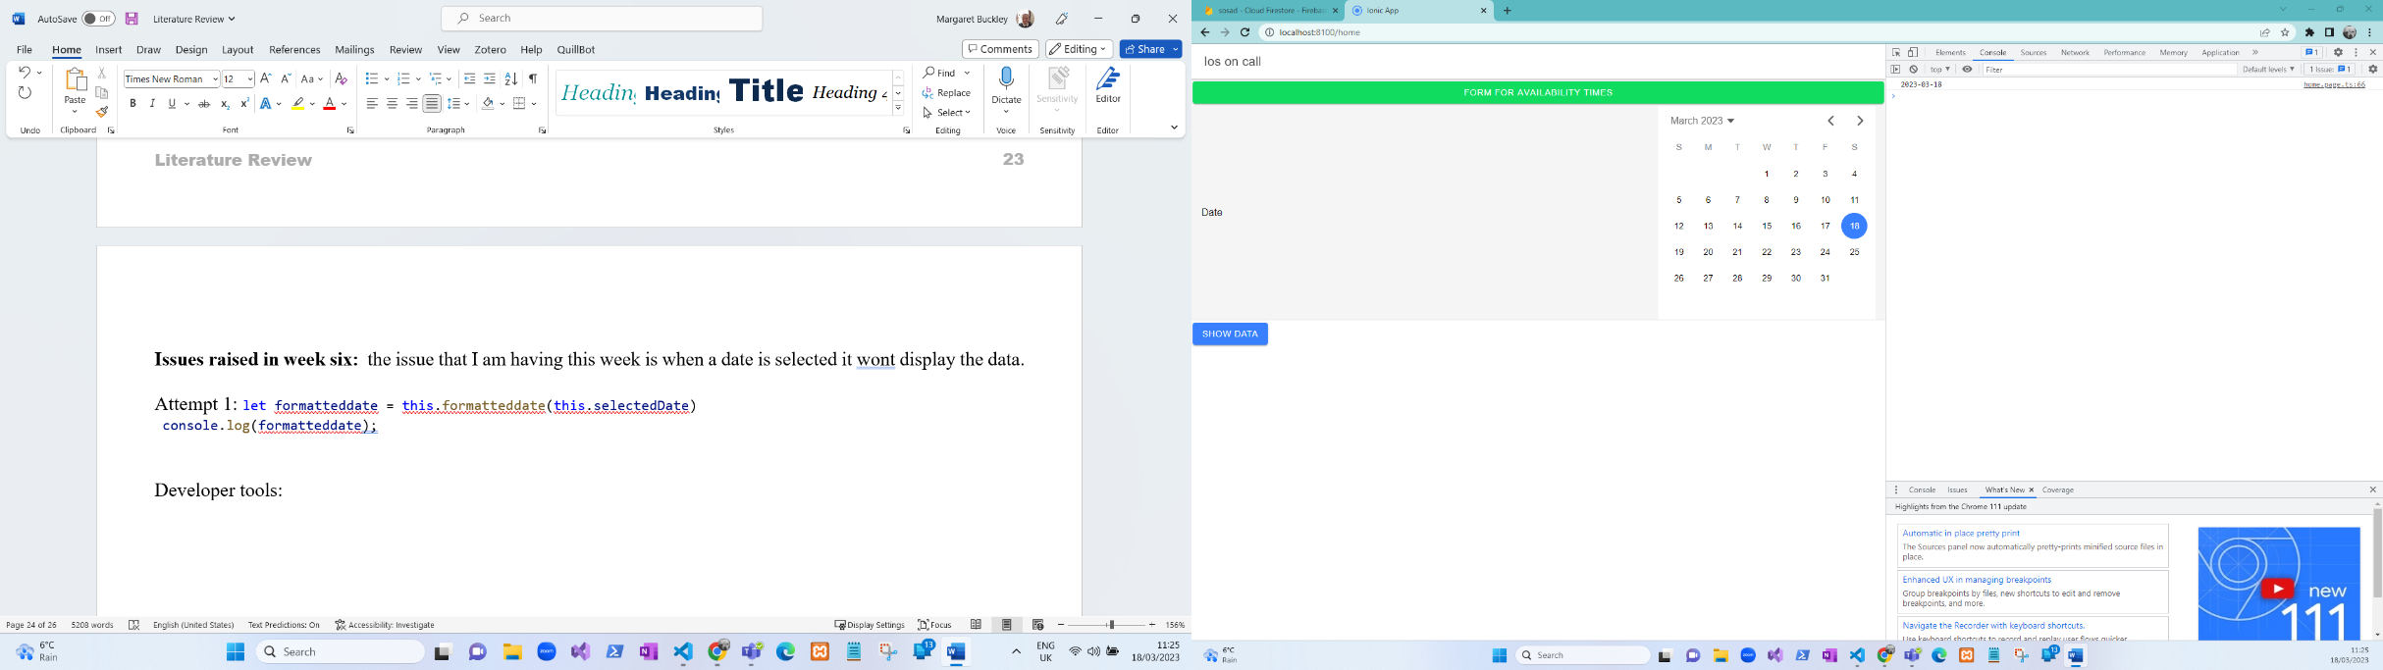Developer tools:

**What’s happening here:** is that its displaying the date but not the data inside of it.

Attempt 2:  const selectedDate = new Date(this.selectedDate);

    console.log(this.selectedDate);

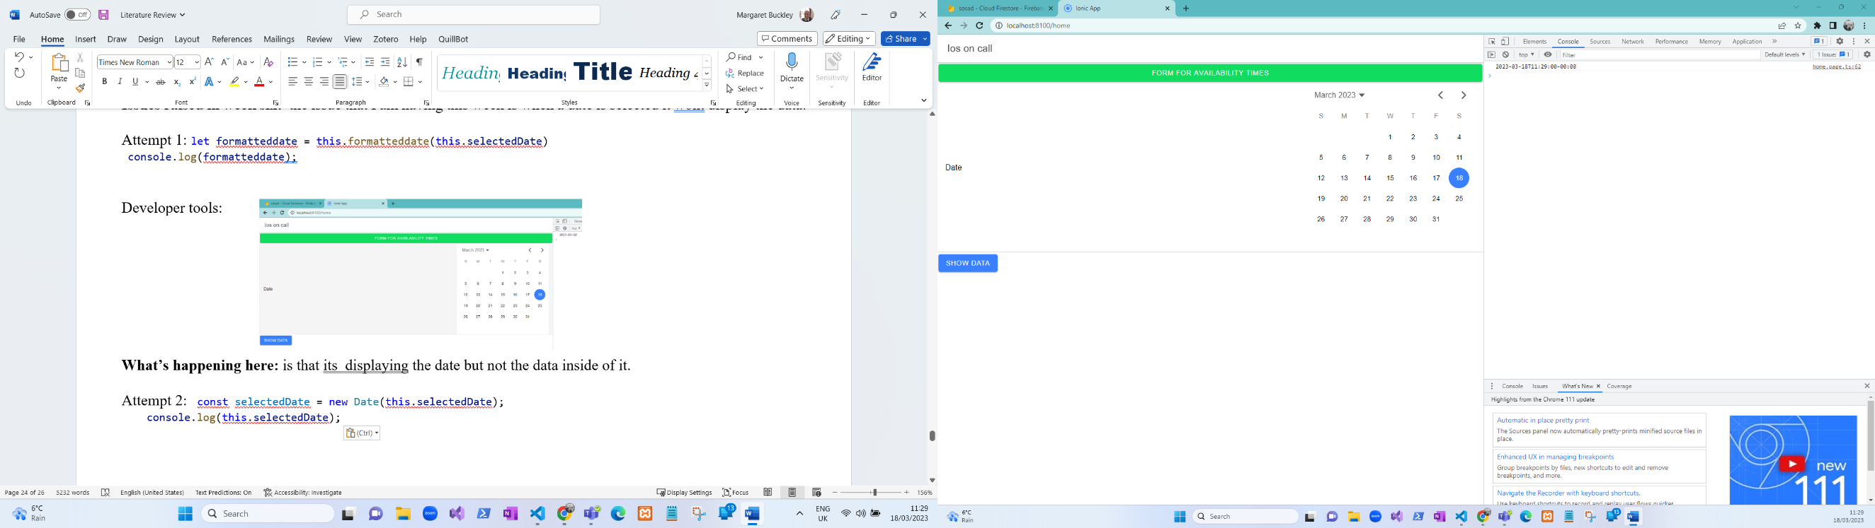Developer tools:

**What’s happening here:** is that it’s displaying the date but not the data inside of it and now its displaying the time.

**Attempt 3:**

  const query1 = await this.firstore.doc("roster/2023-03-18")//.collection('roster').get()

    console.log("query1 " +query1)

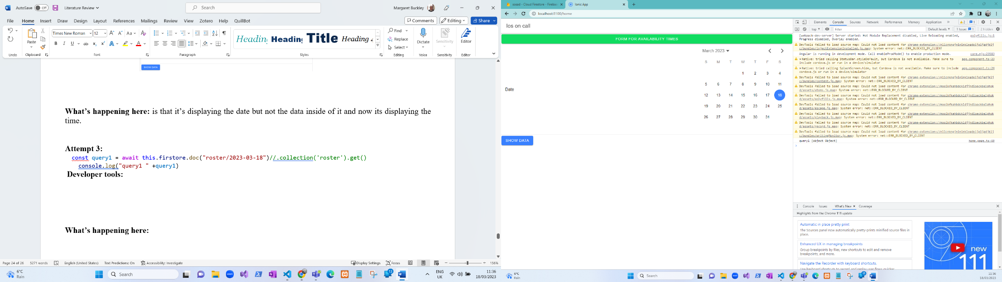 **Developer tools:**

**What’s happening here:** now its returning an object but no data.

## Week 7:

|  |  |  |
| --- | --- | --- |
| **Going to do** | **Tasks** | **Date Completed** |
| Google maps | * Allow users to select an office to find the location of the offices. * Add the interface |  |
|  |  |  |

**Issues raised in week seven:**  the ionic serve -l does not work it doesn’t show the little phones when this command is and the other issue I am having is when I update the app on my phone it throws this error and this error is coming from the google-maps api. The issue with updating the app on my phone is that I have to update the environment variable path.

## **Useful links**

1. <https://imagecolorpicker.com/>: picking colours from images.
2. <https://ably.com/blog/realtime-chat-app-websockets-angular-firebase>: chat
3. <https://masteringionic.com/blog/working-with-capacitor-googlemaps-in-ionic>: google maps
4. <https://github.com/D00196903/Sosad>: GitHub

# References

Queensland Government, UN. *Business Queensland.* [Online]   
Available at: https://www.business.qld.gov.au/running-business/digital-business/online-risk-security/cloud-computing/benefits   
[Accessed 22nd October 2022].

Contributor, T., 2022. *Web application (Web app).* [Online]   
Available at: https://www.techtarget.com/searchsoftwarequality/definition/Web-application-Web-app  
[Accessed 21st October 2022].

Cronkleton, A. B. a. E., 2022. *healthline.* [Online]   
Available at: https://www.healthline.com/health/mental-health/mental-health-apps  
[Accessed 18th November 2022].

Derek, unknown. *7 Benefits of Using MySQL in Your Business.* [Online]   
Available at: https://bootcamp.uxdesign.cc/7-benefits-of-using-mysql-in-your-business-e587e326144f

devs5003, 2022. *javatechonline.* [Online]   
Available at: https://javatechonline.com/types-of-nosql-databases-and-examples/?utm_content=cmp-true  
[Accessed 21st November 2022].

Duggal, N., 2022. *Advantages and Disadvantages of Cloud Computing.* [Online]   
Available at: https://www.simplilearn.com/advantages-and-disadvantages-of-cloud-computing-article

Globaldots, A., 2018. *globaldots.* [Online]   
Available at: https://www.globaldots.com/resources/blog/cloud-computing-benefits-7-key-advantages-for-your-business/  
[Accessed 18th February 2022].

government, q., 2022. *Benefits of cloud computing.* [Online]   
Available at: https://www.business.qld.gov.au/running-business/digital-business/online-risk-security/cloud-computing/benefits

HSE, UN. *hse.* [Online]   
Available at: https://www2.hse.ie/mental-health/services-support/supports-services/  
[Accessed 22nd October 2022].

Iannce, K., 2021. *10 Best Hybrid App Examples.* [Online]   
Available at: https://designli.co/blog/5-best-hybrid-app-examples/  
[Accessed 21st October 2022].

Itrobes, 2021. *Itrobes.* [Online]   
Available at: https://www.itrobes.com/what-are-the-advantages-and-disadvantages-of-web-applications/  
[Accessed 21st October 2022].

Ivy, K. T. H. &., UN. *whatis.* [Online]   
Available at: https://www.techtarget.com/whatis/definition/mobile-app#:~:text=A%20mobile%20app%20(or%20mobile,than%20desktop%20or%20laptop%20computers.  
[Accessed Saturday December 2022].

Jackowski, M., 2020. *asper brothers.* [Online]   
Available at: https://asperbrothers.com/blog/cross-platform-app-development/  
[Accessed 18th November 2022].

Jscrambler, 2022. *12 Frameworks for Hybrid Mobile Apps.* [Online]   
Available at: https://blog.jscrambler.com/12-frameworks-for-mobile-hybrid-apps

Khan, U., 2018. *Clutch.* [Online]   
Available at: https://clutch.co/app-developers/resources/pros-cons-native-apps  
[Accessed 21st October 2022].

Lannace, K. K., 2021. *Designli.* [Online]   
Available at: https://designli.co/blog/5-best-hybrid-app-examples/  
[Accessed 21st October 2022].

Microsft, UN. *What is cloud computing?.* [Online]   
Available at: https://azure.microsoft.com/en-in/resources/cloud-computing-dictionary/what-is-cloud-computing/  
[Accessed 21st October 2022].

Mishal, 2021. *7 Advantages and Disadvantages of Hybrid Apps | Limitations & Benefits of Hybrid Apps.* [Online]   
Available at: https://www.hitechwhizz.com/2021/04/7-advantages-and-disadvantages-limitations-benefits-of-hybrid-apps.html

Morin, A., 2022. *Best Mental Health Apps.* [Online]   
Available at: https://www.verywellmind.com/best-mental-health-apps-4692902

Pattinson, T., 2022. *Relational vs. Non-Relational Databases.* [Online]   
Available at: https://www.pluralsight.com/blog/software-development/relational-vs-non-relational-databases

Pattinson, T., 2022. *Pluralsight.* [Online]   
Available at: https://www.pluralsight.com/blog/software-development/relational-vs-non-relational-databases  
[Accessed 23rd October 2022].

TechMango, 2022. *TechMango.* [Online]   
Available at: https://www.techmango.net/what-are-the-benefits-of-cross-platform-application-development   
[Accessed 21st October 2022].

UN, 2022. *HSE.* [Online]   
Available at: https://www2.hse.ie/mental-health/services-support/supports-services/  
[Accessed Friday November 2022].

unknown, 2020. *What is Cross-Platform App Development?.* [Online]   
Available at: https://fullscale.io/blog/what-is-cross-platform-app-development/

unknown, 2021. *What are the advantages and disadvantages of web applications?.* [Online]   
Available at: https://www.itrobes.com/what-are-the-advantages-and-disadvantages-of-web-applications/

unknown, 2022. *5 Key Benefits of Native Mobile App Development.* [Online]   
Available at: https://clearbridgemobile.com/benefits-of-native-mobile-app-development/#:~:text=Native%20apps%20are%20very%20fast,leverage%20the%20device's%20processing%20speed.

unknown, 2022. *Mental health supports and services.* [Online]   
Available at: https://www2.hse.ie/mental-health/services-support/supports-services/

unknown, 2022. *Native Apps, Web Apps or Hybrid Apps? What’s the Difference?.* [Online]   
Available at: https://www.mobiloud.com/blog/native-web-or-hybrid-apps

unknown, 2022. *Native Apps, Web Apps or Hybrid Apps? What’s the Difference?.* [Online]   
Available at: https://www.mobiloud.com/blog/native-web-or-hybrid-apps  
[Accessed 21st October 2022].

unknown, 2022. *What are the Benefits of Cross-platform Application Development?.* [Online]   
Available at: https://www.techmango.net/what-are-the-benefits-of-cross-platform-application-development

UN, UN. *software testing help.* [Online]   
Available at: https://www.hostinger.com/tutorials/web-development-tools  
[Accessed 20th November 2022].